**SAP Project Management**

App Name: Project Control

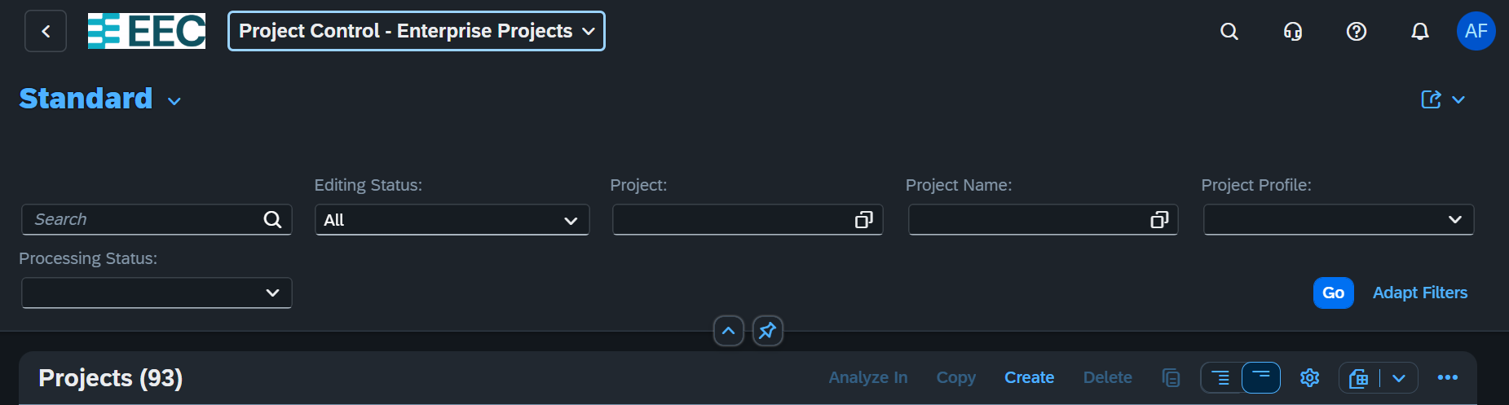

Click create Button

Afet project have been created we can configure also WBS by Click More Apps

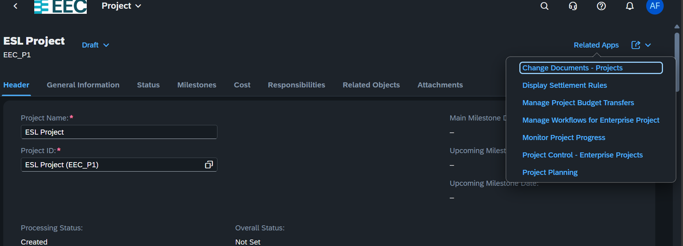

Then select The App and Click Edit to Add More

Inside the Project Planning we can create a work breakdown structure(WBS)

To Manage the Breakdowns we can use Indentation tab

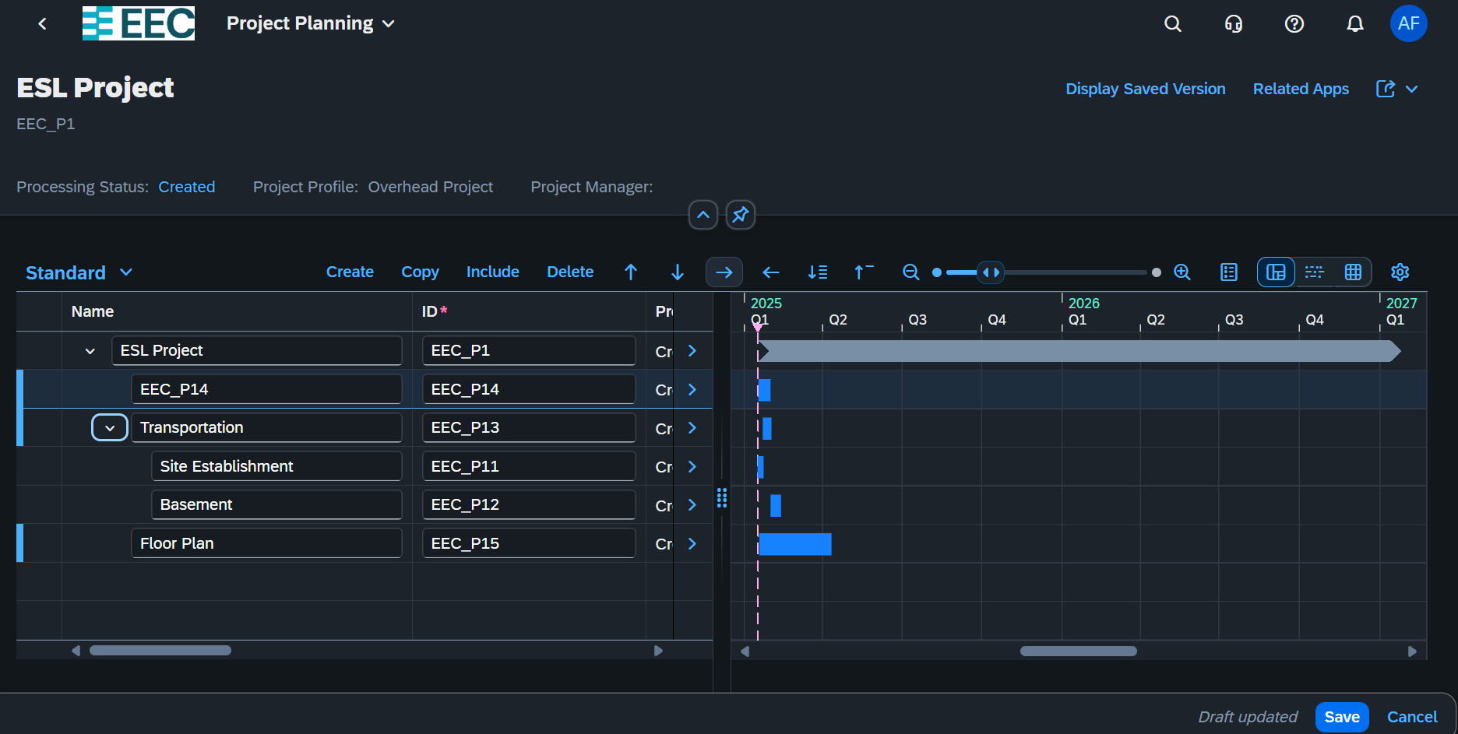

Reporting part

App Name: **monitor Project**